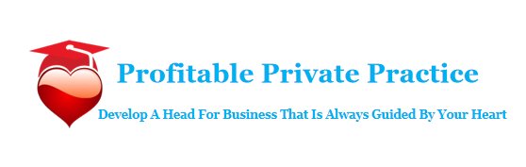
The Secret To
Creating & Packaging Your Irresistible Offers

This ‘secret’ is something you use in your everyday life yet it’s often completely overlooked by business owners. As you know there are many moving parts that make up a successful Practice:
. A well-designed website that makes your ideal client feel connected to you.
Content, consistency and planning to maintain a highly visible profile and you’re looking forward to receiving lots of enquire from potential clients eager to work with you—so let’s make sure we come up with some powerful packages and product ideas.
Let’s begin with this essential step…

STEP ONE: DETERMINE YOUR RANGE
Before you rush to create programs and offers, you will need to put some thought into how you can find a balance between your potential client’s budget and your income goals.
You should have 3 income goals:
- The amount you need to earn to meet your financial commitments now.
- The amount you would like to earn; an amount that makes it possible for you to save and have fun.
- The amount that would have you doing the happy dance around the kitchen :)

This will guide the kind of packages & products you create and the kind of clients you decide to work with.

The next step is to consider these two questions:
- Will you only consider working with clients whose income range is in the six figure range?
- Or is your client on a journey: One that will see her start out in one income bracket and progress to a higher bracket?
If your answer was (a):
Focus on high end packages, such as:
- One-on-one coaching
- Elite coaching
- Mastermind coaching
You can also branch out, as Kristen Eckstein does with her book ‘Ninja brand’, and offer complete “done-for-you” services, from A to Z. (Strictly speaking, this is not under the umbrella of “coaching,” but there is no reason you can’t fast-track clients by setting them up with services that will get them up and running quickly and professionally—and it can be very lucrative, since you will charge top price for the convenience.)
If your answer was (b):
- Determine at what income bracket your ideal client is starting out
- Determine where she is likely to end up
- Create a range of products and packages priced accurately for each stage, to help her get from her particular A to her particular Z
This range of products could include:
- Public (large group) membership site or forum
- Books
- Workbooks
- Worksheets
- Recordings
- Videos
- On-demand webinars
- Email mini-courses
- “Lite” versions of your more expensive packages
- One-off “strategy sessions”
All of these can be made affordable to the lowest end of your client financial spectrum—but all should prime and position your purchasers to:
- Achieve the next level of success
- Be able to choose your higher-end packages and products

STEP TWO: DETERMINING HOW YOU WORK BEST
Your delivery system is another factor to consider. Where do you shine best? What feels most natural to you and—more important—what do clients seem to achieve the most satisfaction with?
- One-on-one in person sessions
- Elite group in-person sessions
- One-on-one Elite or Mastermind coaching
- Mastermind retreats for a small number of clients
How you deliver can also affect your ease of delivery: For example, if you hate telephone coaching, but love being able to see clients and work face to face, gauging their body language and reactions, then one-on-one video sessions via Skype or Zoom is a great way to achieve the connection of “in-person” sessions.
You can offer one-on-one coaching:
- By email
- By telephone
- Via video Skype and Zoom….I prefer Zoom as I find it more reliable.
- In person
Or any combination of the above. (It also depends on your client’s preferences and comfort level, too!)
You can approach working with small or large groups the same way:
- Via webinar
- Via teleseminar
- Via Google+ Hangout
- At a Mastermind Retreat
- At a large, live event
And remember that you can also team up with other professionals and experts, who offer services that compliment yours at events, offering a combination of delivery styles and offerings:
- Promote your book
- Offer a limited number of one-on-one sessions
- Give a classroom-sized group session
- Join in a round-table panel discussion
- Give a keynote speech
(The latter is a great way to introduce yourself to a large audience, so if anyone wants you to do this, take a note from the movie “Ghostbusters” (1984) and say “YES!”)
How to Test the Waters:
If you want to test out various delivery systems, first do so locally.
- Offer a workshop to your community niche members or local groups
- Volunteer to “donate” a class or offer a day of one-hour sessions
Here’s what you’ll get out of it (besides the joy of helping your neighbours and community peers):
- Include a “feedback form” as part of your donated time, asking participants to comment on specific things they:
  - Liked—or didn’t like
  - Got—or didn’t get (and wanted)
  - Felt comfortable—or uncomfortable—with
- Tell your participants about the form at the beginning of your session or presentation, so they know it will be coming. Specifically ask them to stick around at the end of the session and fill in your short feedback form.
- Elect a volunteer from the audience to hand the forms out at break time (if you are speaking to a group of clients)
- Remind clients to fill the feedback form out at the end of your session.
Keep your questions short and easy to answer.
You can also offer one-on-one sessions by telephone, Zoom and in person as a prize, during your donated event. (Just be sure you are observant with local laws on contest types and prizes)
All this provides you with great market research, experience and confidence before you commit yourself too much further on specific delivery models.
It also helps you to begin right at local, grass-roots level to take one more important action…
Now let’s get to the real meat of this section: How to create and package your offers.
Important Point To Note: Working to your strengths is great however the chances of you setting up a successful Practice hinges on your willingness to stretch and grow and move out of your comfort zone. Consistent income depends upon your consistent growth.

STEP THREE: PACKAGING AND STRUCTURING YOUR OFFERS
Just as we saw there is more than one type of delivery system, we also saw there is more than one way to combine them. Rather than offering simple “sessions,” you can put these into special offers and package deals to maximize your profits even more.
Creating a package deal will dramatically increase your income and your clients ability to create lasting changes.
If you package your services correctly, it should feel as if you have done your client a huge favour; providing at least three times more value than the amount they’ve paid.
Always, always, always aim for a win- win outcome!!
Also consider sweetening your offers with “extras” like fast-action bonuses and early-bird discounts.

STEP FOUR: ADDING VALUE TO YOUR OFFERS
We both know that offering single sessions is rarely going to help a client overcome issues they’ve been struggling with for years. And even if you use a method that you believe can achieve amazing results in record time, trying to convince a client of that can be very difficult.

It also places you under a lot of pressure to deliver which is counter productive.

Don’t you think it makes more sense to create a longer, more comprehensive package which combines online education and support with in person sessions?
This enables you to work at a much deeper level with your clients and increases the chances that your clients will make changes that last.

It really is a win-win situation

STEP FIVE: PLANNING YOUR SALES PROCESS
This is the type of thinking you need to apply to every offer in your sales process. You have to get out of the habit of thinking:
Product + online Landing page / phone call or meeting = OFFER
Instead, you can consider offering services on a sliding scale: The higher the ticket price, the more you need to add social proof; added-value tailored options such as payment plans (not for every Practitioner); high-value extra products and special offers—all while tailoring these exactly to your perfect client.
You need to think in terms of:
Product + online Landing Page / phone call or meeting + Options + Upgrades + Proof = OFFER
In short, you don’t just need a series of offers or products: You need a professionally-planned and researched sales process, starting with ways to attract a broad base of prospective clients in your chosen area, and ending up with your high-end options such as one-on-one coaching and even deluxe, all-inclusive retreats.
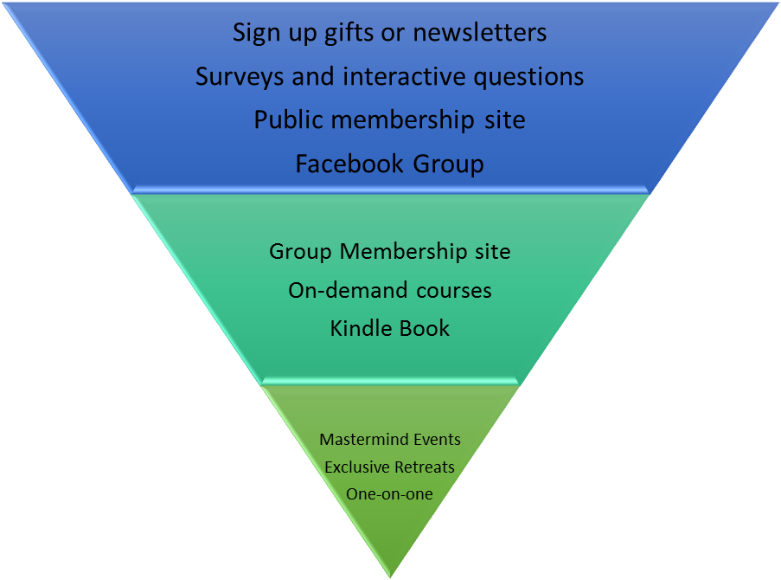

Your sales process needs to be based on informed thinking and research that allows you to predict:
- The life cycle of your average client—will your client make it all the way through to your high-end offers?
- Her income range—at what point in the process does she have to financially opt out?
- Retention strategies—can you prolong her stay in your process? Offer payment options? Demonstrate the return on any further investment will outweigh current sacrifices?
- Exactly what will bond her to you and cause her to stay?
As simple a problem as not allowing her to pay through PayPal, Stripe (or, conversely, by credit card) can cause early exits.
As simple a bonus as offering to include a copy of your signature Kindle book can tip the scales towards purchases.
STEP FIVE: PUT YOURSELF IN YOUR CLIENTS SHOES
When you brainstorm products and offers for your Private Practice,think about the difficulties your ideal client is facing and brainstorm as many solutions as possible. Write them down—no matter how wild they may seem. Then go through the list and, again, look at these ideas through the eyes of your ideal client. Imagine her reacting to each offer. When you get one that clicks, think of:
- What might put her off
- What might cause her to click the “Buy” button
Come up with a unique angle or tap into a hidden market in a similar way a lady by the name of Kelly McCausey. Kelly organised ‘Beachpreneur’ retreat events and she labelled these “introvert friendly” tailored these towards entrepreneurs with confidence issues (on top of the already-inspired, lifestyle-at-the-beach setting!)
Finally, give them recognizable, great names that mean something emotionally—like “Beachpreneurs.”
Your offers should stand out from your competitors’ offers, by being unique and having a strong identity and combine interesting elements.
In our next module, we’ll talk about adding passive income to your coaching offers.
See you there!

